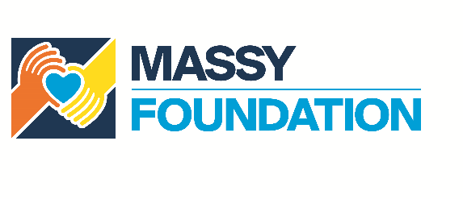

**APPLICATION AND PRE-SCREENING FORM**

|  |  |  |
| --- | --- | --- |
|  | ABOUT YOUR ORGANISATION |  |
| 1 | Organisation name  Organisation address  Contact person name  Contact person phone number  Who are your directors/leaders?   * Name * Title * Email * Tel * Expertise   Organisation type:   * Non-Governmental Organisation (NGO) * Community-Based Organisation (CBO) * Faith-Based Organisation (FBO) * School/Educational Facility * Club * Other ___________________________   In what year did your organisation begin operations?  Is your organisation a registered body?   * Yes – upload certificate * No – upload letter from your area MP/Regional Corporation verifying your work in the community   Please identify your affiliation (if any) with the Massy Group   * Employee * Company * Relationship   Have you applied for funding from the Massy Foundation before?   * Yes – have you received funding?   + Yes – list amount and year(s)   + No * No |  |
|  | **PROJECT COST** |  |
| 2 | What is the title of your project?  What is your total project cost?   * Please attach an itemized budget   How much are you requesting from the Massy Foundation?  Does this project have other sponsors?   * List Potential * List Confirmed * No |  |
|  | **PROJECT OBJECTIVES** |  |
| 3 | Select the sector(s) that the project supports:   * Arts & Culture * Community Development * Education * Environment * Health & Wellness * Poverty Alleviation * Sport * Youth * Other (State) |  |
| 4 | Select the town/village/community where the project will have the most impact:   * List communities...   Is there a definitive timeframe for this project?   * Yes – list start and end dates * No – explain |  |
| 5 | How does your project impact your target group and / or community?  How do you measure this impact?  How long will the impact last?  Where the project involves training, how will this training be utilized after the project is completed? |  |
|  | **BENEFICIARIES** |  |
|  | Target group – age, gender, profession, etc.  How are your beneficiaries selected?  Number of beneficiaries? |  |
|  | **SUSTAINABILITY** |  |
| 6 | How do you raise funding/assistance for your project?   * International Agencies | % of Total Raised * Corporate Grants | % of Total Raised * Government Subventions | % of Total Raised * Income Generating Activities | % of Total Raised * Other | % of Total Raised |  |
| 7 | Who are your current funders/sponsors?   * Entity * $$ Amount or In-Kind Contribution * Period of Funding * Purpose of Funds   What resources will your organisation be contributing directly to the project? |  |
| 8 | Please outline how you intend to fund this project on an ongoing basis/until completion  How will your project be monitored/evaluated while being implemented? |  |
| 9 | If a registered organisation, please attach your last audited financial statements  If unaudited, please indicate why |  |
|  | **EXPERIENCE** |  |
| 10 | Please describe the most recent and relevant project your organisation has undertaken   * Project Name * Project Description * Project Timeframe * Project Objectives * Project Cost * Project Sponsors * Were the objectives achieved?   What other projects of a similar nature have you undertaken in the past 3 years?   * Project Name * Project Description * Project Timeframe * Project Objectives * Project Cost * Project Sponsors * Were the objectives achieved? |  |
|  | **ADDITIONAL INFORMATION** |  |
| 11 | Please provide references from two independent organisations  Where applicable, please provide three quotations for items being requested |  |